EXP. NO: 9 PERFORMANCE EVALUATION OF AM GENERATION AND
DETECTION UNDER NOISY CHANNEL CONDITIONS USING MATLAB

PROGRAM:

clc; clear; close all;
fs = 100000; t = 0:1/fs:0.02;
fm = 500; fc = 5000;
m = cos(2*pi*fm*t);
c = cos(2*pi*fc*t);
am = (1+m).*c;
noisy = awgn(am,10,'measured');
env = abs(hilbert(noisy));
figure;
subplot(5,1,1); plot(t,m); title('Message Signal'); grid on;
subplot(5,1,2); plot(t,c); title('Carrier Signal'); grid on;
subplot(5,1,3); plot(t,am); title('AM Signal'); grid on;
subplot(5,1,4); plot(t,noisy); title('AM Signal with Noise'); grid on;
subplot(5,1,5); plot(t,env); title('Recovered Signal'); grid on;

WAVEFORM:

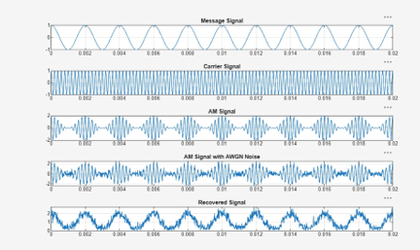

OUTPUT:
